

**Hues of Holi celebration at Agastya Academy!**

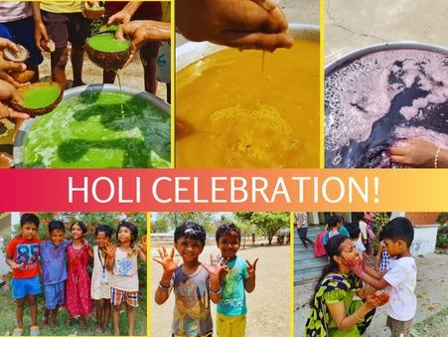

At Agastya Academy, Nature's vibrant palette bloomed as the spirit of Holi was celebrated in an eco-friendly manner. Children enthusiastically engaged in handcrafting Holi colours using natural ingredients such as Neem for greens, Turmeric for yellow, and Beets for red, adding a touch of authenticity to the festivities. The atmosphere filled with laughter and joy as tubs of these natural hues mixed with water adorned the place, promoting a safe and sustainable celebration. Amidst the colourful ambiance, children danced with boundless energy, spreading happiness and creating lasting memories.

[Click here to read more………..](https://www.agastyaacademy.edu.in/post/hues-of-holi-celebrations-at-agastya-academy)